Ideation Phase
Define the Problem Statements

Date: 18 February 2026
Team ID: LTVIP2026TMIDS4411
Project Name: ShopEZ:One-Stop Shop for Online Purchases
Maximum Marks: 2 Marks
Customer Problem Statement – Shopez Edition
A well-crafted customer problem statement helps your team focus on what truly matters: solving real pain points. For Shopez, the goal is to create a seamless,
inclusive, and scalable shopping experience. Here’s the template applied to your project:
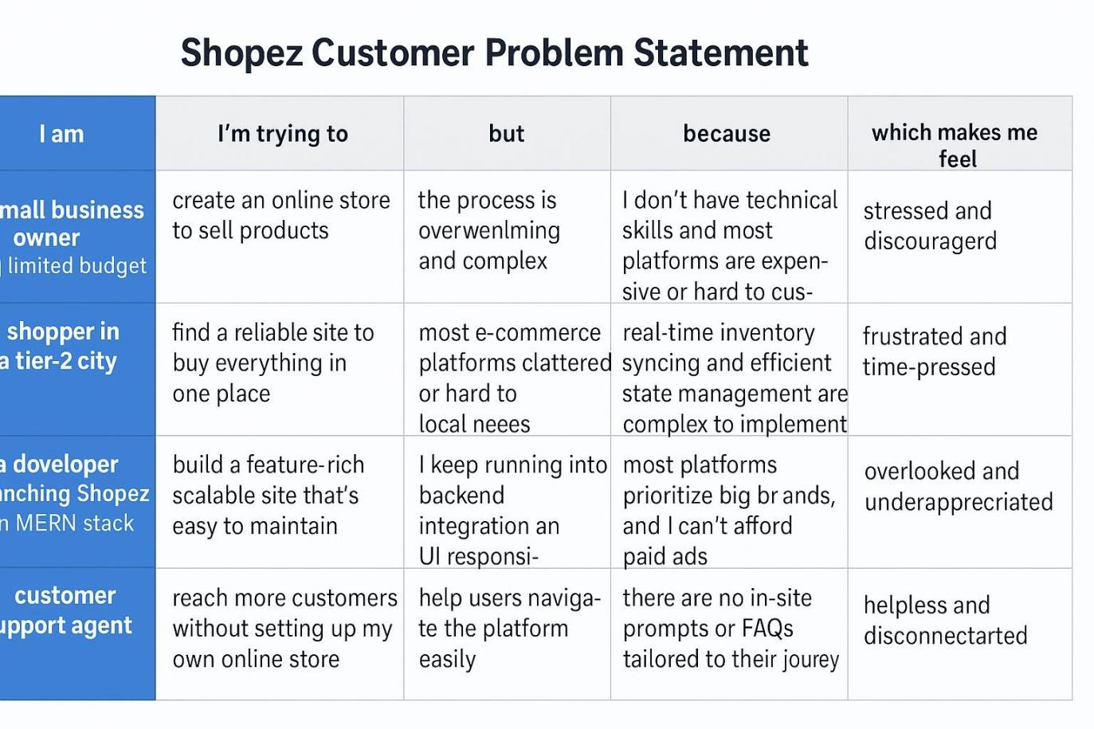
Reference:https://github.com/MittanaBhagyalaxmi33/SHOPEZ-MERNSTACK-APPLICATION

Example:
